# **Name: Abdurrahman Qureshi**

# **Roll No: 210451**

Practical No: 7

**1)** **Develop a program to demonstrate the use of tree component in swing.**

**CODE:**

import javax.swing.*;

import javax.swing.tree.DefaultMutableTreeNode;

import java.awt.*;

public class Main {

public Main() {

JFrame frame = new JFrame("Tree Component Demo");

DefaultMutableTreeNode root = new DefaultMutableTreeNode("Root");

DefaultMutableTreeNode folder1 = new DefaultMutableTreeNode("Folder 1");

DefaultMutableTreeNode folder2 = new DefaultMutableTreeNode("Folder 2");

DefaultMutableTreeNode file1 = new DefaultMutableTreeNode("File 1");

DefaultMutableTreeNode file2 = new DefaultMutableTreeNode("File 2");

root.add(folder1);

root.add(folder2);

folder1.add(file1);

folder2.add(file2);

JTree tree = new JTree(root);

JScrollPane scrollPane = new JScrollPane(tree);

frame.add(scrollPane);

frame.setSize(400, 300);

frame.setDefaultCloseOperation(JFrame.EXIT_ON_CLOSE);

frame.setVisible(true);}

public static void main(String[] args) {

new Main();

}

**OUTPUT:**

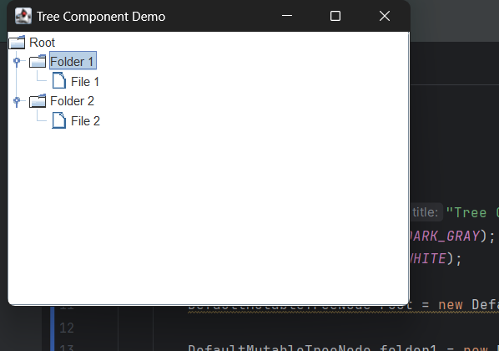

**2)Generate the following output**

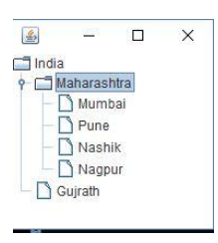

**CODE:**

import javax.swing.*;

import javax.swing.tree.DefaultMutableTreeNode;

import java.awt.*;

public class Main {

public Main() {

JFrame frame = new JFrame("My Tree Component Demo");

frame.setBackground(Color.DARK_GRAY);

frame.setForeground(Color.WHITE);

DefaultMutableTreeNode root = new DefaultMutableTreeNode("India");

DefaultMutableTreeNode folder1 = new DefaultMutableTreeNode("Maharashtra");

DefaultMutableTreeNode folder2 = new DefaultMutableTreeNode("Gujarat");

DefaultMutableTreeNode file1 = new DefaultMutableTreeNode("Mumbai");

DefaultMutableTreeNode file2 = new DefaultMutableTreeNode("Pune");

DefaultMutableTreeNode file3 = new DefaultMutableTreeNode("Nashik");

DefaultMutableTreeNode file4 = new DefaultMutableTreeNode("Nagpur");

root.add(folder1);

root.add(folder2);

folder1.add(file1);

folder1.add(file2);

folder1.add(file3);

folder1.add(file4);

JTree tree = new JTree(root);

JScrollPane scrollPane = new JScrollPane(tree);

tree.setBackground(Color.DARK_GRAY);

tree.setForeground(Color.WHITE);

tree.setSize(400,300);

frame.add(scrollPane);

frame.setSize(400, 300);

frame.setDefaultCloseOperation(JFrame.EXIT_ON_CLOSE);

frame.setVisible(true);

}

public static void main(String[] args) {

new Main();

}

}

**OUTPUT:**

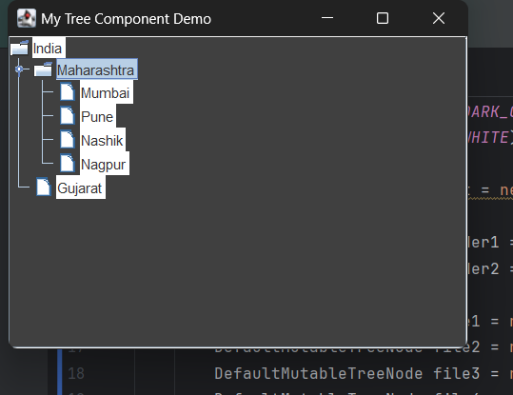

**3)** **Write a Jtree program to show root directory and its subFolders of your System**

**CODE:**

import javax.swing.*;

import javax.swing.tree.DefaultMutableTreeNode;

import java.awt.*;

public class Main {

public Main() {

JFrame frame = new JFrame("My System Tree"); frame.setBackground(Color.DARK_GRAY);

frame.setForeground(Color.WHITE);

DefaultMutableTreeNode root = new DefaultMutableTreeNode("This PC");

DefaultMutableTreeNode folder4 = new DefaultMutableTreeNode("Windows");

DefaultMutableTreeNode folder3 = new DefaultMutableTreeNode("Users");

DefaultMutableTreeNode folder1 = new DefaultMutableTreeNode("qarq90");

DefaultMutableTreeNode folder2 = new DefaultMutableTreeNode("Program Files");

DefaultMutableTreeNode file1 = new DefaultMutableTreeNode("Diploma");

DefaultMutableTreeNode file2 = new DefaultMutableTreeNode("Lock Screen");

DefaultMutableTreeNode file3 = new DefaultMutableTreeNode("Softwares");

DefaultMutableTreeNode file11 = new DefaultMutableTreeNode("Git");

DefaultMutableTreeNode file12 = new DefaultMutableTreeNode("JetBrains");

DefaultMutableTreeNode file13 = new DefaultMutableTreeNode("CClearner");

root.add(folder1);

root.add(folder2);

root.add(folder3);

root.add(folder4);

folder1.add(file1);

folder1.add(file2);

folder1.add(file3);

folder2.add(file11);

folder2.add(file12);

folder2.add(file13);

JTree tree = new JTree(root);

JScrollPane scrollPane = new JScrollPane(tree);

tree.setBackground(Color.DARK_GRAY);

tree.setForeground(Color.WHITE);

tree.setSize(400,300);

frame.add(scrollPane);

frame.setSize(400, 300);

frame.setDefaultCloseOperation(JFrame.EXIT_ON_CLOSE);

frame.setVisible(true);

}

public static void main(String[] args) {

new Main();}}

**OUTPUT:**

